We can install nexus with docker also

Create Installation Directory:

mkdir /opt/nexus

cd /opt/nexus

Download Nexus Repository OSS:

wget http://www.sonatype.org/downloads/nexus-latest-bundle.tar.gz

tar -xzvf nexus-latest-bundle.tar.gz

ln -s nexus-3.0.0-03-unix.tar.gz nexus

Copy Init Script:

cp /opt/nexus/nexus/bin/nexus /etc/init.d/

Change the Init Script:

Edit the **/etc/init.d/nexus** Init script, and edit the following line.

NEXUS_HOME="/opt/nexus/nexus"

Add the Nexus User.

useradd nexus

Set directory permissions:

chown -R nexus:nexus /opt/nexus/

chown nexus:nexus /etc/init.d/nexus

Add firewall rules:

firewall-cmd --zone=public --permanent --add-port=8081/tcp

firewall-cmd --reload

Set the application context:

Edit the **/opt/nexus/nexus/conf/nexus.properties** and set the webapp context. This will remove the virtual directory of **nexus**out of the URL Path.

nexus-webapp-context-path=/nexus

Start Nexus Service:

su nexus

/etc/init.d/nexus start

chkconfig nexus on

**another type**

## Installing and Running with the Distribution Archive

The distribution archives combine the application and all required resources in an archive file.

If you are installing the repository manager on a local workstation to give it a test run, you can install it in your home directory or wherever you like. Nexus Repository Manager doesn’t have any hard-coded directories and will run from any directory.

You can extract the archive ZIP for Windows with any archiving tool like [7zip](http://www.7-zip.org/download.html) or on the command line.

On Windows you should install the repository manager outside Program Files to avoid problems with Windows file registry virtualization. If you plan to run the repository manager as a specific user you can install it into the AppData\Local directory of that users home directory. Otherwise simply use e.g., C:\nexus or something similar, ensuring that the user running the application has full access.

On OSX or Linux the downloaded GZip’d TAR archive can be extracted with the command tar xvzf.

You install the repository manager in a directory other than your users home directory. On a Unix machine common practice is to use /opt.The extraction process creates two sibling directories: an application directory and a data directory, sometimes called the "Sonatype work" directory. Further details about these folders and their contents can be found in [Directories](https://help.sonatype.com/repomanager3/installation/directories).

The bin folder contains the generic startup scripts for Unix-like platforms called nexus. The Windows platform equivalent is called nexus.exe.

To start the repository manager from application directory in the bin folder on a Unix-like platform like Linux use:

./nexus run

The equivalent invocation on Windows requires a / in front of the run and any other commands.

nexus.exe /run

Starting the repository manager with the run command will leave it running in the current shell and display the log output.

Startup is complete when the log shows the message "Started Sonatype Nexus".

In order to shut down the repository manager running via the run command, you have to press CTRL-C.The nexus script can be used to manage the repository manager as a background application on OSX and Unix with the start, stop, restart, force-reload and status commands. The Windows nexus.exe command supports similar commands with a prefix of / e.g., /start. Once the repository manager is started you can access the user interface as detailed in [Accessing the User Interface](https://help.sonatype.com/repomanager3/installation/accessing-the-user-interface).

To uninstall the repository manager from an archive installation, remove the service configuration and delete the entire directory.

**Another type**

### Download and Install Nexus

sudo wget http://www.sonatype.org/downloads/nexus-latest-bundle.zip

sudo chmod 777 nexus-2.11.4-01-bundle.zip

sudo unzip nexus-2.11.4-01-bundle.zip

cd nexus-2.11.4-01/bin

sudo RUN_AS_USER=root ./nexus start

**Another type**

### Nexus 2.X Installation on Linux

# cd /tmp/

# wget http://www.sonatype.org/downloads/nexus-latest-bundle.tar.gz

# tar -xvzpf nexus-latest-bundle.tar.gz

# mkdir -p /opt/nexus/2.13.0

# mv nexus-2.13.0-01/* /opt/nexus/2.13.0/

# ln -s /opt/nexus/2.13.0/ /opt/nexus/current

# chown -R <username> /opt/nexus/

$ su - <username>

$ vi ~/.bash_profile

#### NEXUS 2.13.0 #########################

export NEXUS_HOME=/opt/nexus/current

export PATH=$PATH:$NEXUS_HOME/bin

#### NEXUS 2.13.0 #########################

$ source ~/.bash_profile

$ nexus start

$ nexus status

Nexus OSS is running (150).

wait 2-3 minutes

$ curl -I http://localhost:8081/nexus/

HTTP/1.1 200 OK

Date: Sat, 28 May 2016 12:31:49 GMT

Server: Nexus/2.13.0-01

X-Frame-Options: SAMEORIGIN

X-Content-Type-Options: nosniff

Content-Type: text/html

Last-Modified: Sat, 28 May 2016 12:31:49 GMT

Content-Length: 8026

Pragma: no-cache

Cache-Control: post-check=0, pre-check=0

Expires: 0

http://localhost:8081/nexus/

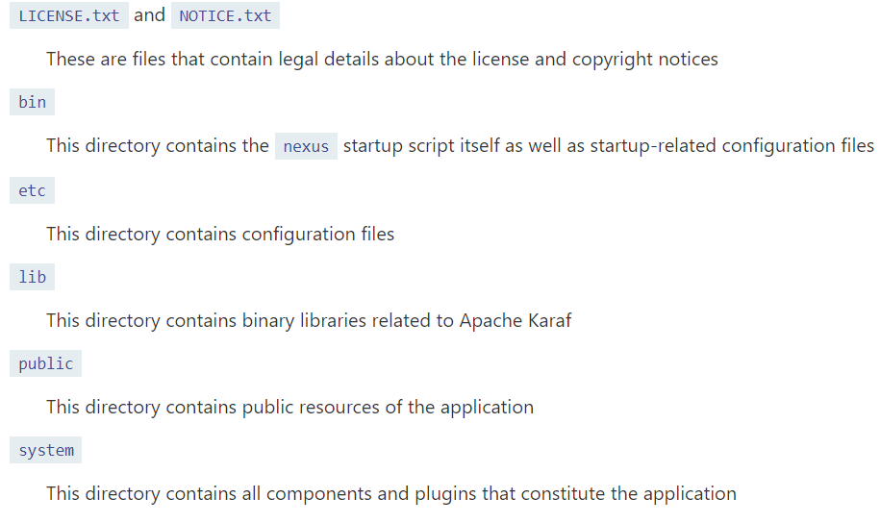

“log” folder contains the logs of nexus